# Problem Statement

**Objective:**

To analyze the dataset that will help to create a model that will predict the cost of medical insurance based on various input features.

**Problem Statement:**

An insurance agency, ABC Insurance, has a large dataset containing information about their policyholders and claims. They want to perform exploratory data analysis (EDA) on this dataset to gain insights that can help them make better business decisions and improve their operations.

The agency wants to analyze the different body types and the environment that affect the premium. The disease's effect or the cost of treatment differs depending on the circumstances. For example, a smoker's medical insurance premium may be higher than that of a healthy person, because smokers are more likely to develop chronic diseases. The agency wants to analyze the data to research healthcare premium costs.

**Domain:** Healthcare

**Dataset:** insurance dataset (insurance.csv)

**Dataset Description:**

|  |  |
| --- | --- |
| **age** | Age of the person |
| **sex** | Female or Male |
| **BMI** | BMI value to estimate an individual's health and fitness condition |
| **children** | number of children (1,2,3,4, or 5) |
| **smoker** | The person is a smoker or not |
| **region** | Specifies the region (northeast, northwest, southeast, southwest) |
| **charges** | the amount of insurance |

# Task

1. Import libraries such as Pandas, matplotlib, NumPy, and seaborn and load the insurance dataset

1. Check the shape of the data along with the data types of the column

1. Check missing values in the dataset and find the appropriate measures to fill in the missing values

1. Explore the relationship between the feature and target column using a count plot of categorical columns and a scatter plot of numerical columns

### Observation:

* The dataset is almost evenly distributed among genders, with 676 Males (50.5%) and 662 Fenales (49.5%)

### Observation:

* All four regions are represented approximately evenly in the dataset.

### Observation:

* In the dataset, approximately 85% (1138 / 1338) of the insured have less than 3 children.

1. Perform data visualization using plots of feature vs feature

A partcularly interesting relationship between Insurance Premium Charges, BMI and Smoking status (Smoker / Non - smoker) can be seen in this graph.

### Observation:

* From the correlation heatmap, we can conclude that the premium charges show a weak positive correlation with Age and BMI of the insured, and a strong positive correlation with smoking habit.

1. Check if the number of premium charges for smokers or non-smokers is increasing as they are aging.

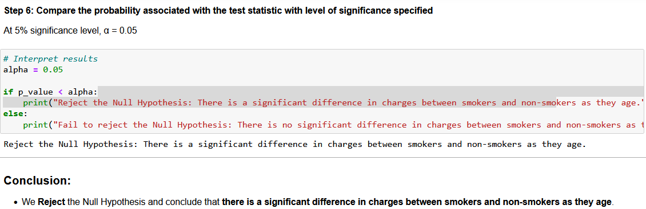

1. After each step, specify the observations